



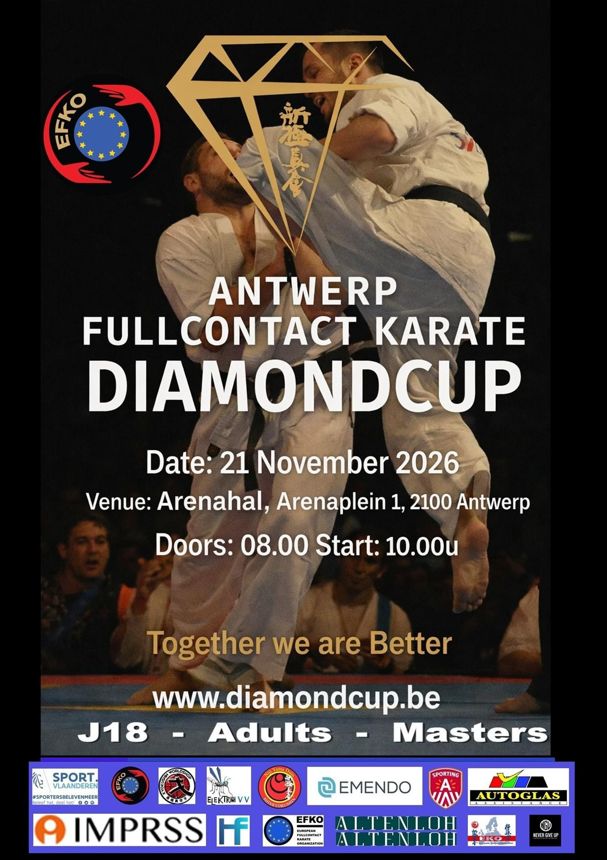
Antwerp Fullcontact Karate Diamondcup 2026

Shihan Koen Spitaels Invitation & Guidelines
Shihan Koen Spitaels

Niji Yama Dojo vzw
WELCOME

Dear Presidents, Country Representatives, WKO Branch Chiefs, National Coaches, Dear Shihan, Sensei, Senpai, Dojo Leaders and Karateka’s,
On behalf of the Belgian Karate Organisation Shinkyokushin (BKOS), the European Fullcontact Karate Organization EFKO and Niji Yama Dojo, we are very honored and proud to invite you to the

“Antwerp Fullcontact DIAMOND CUP 2026”

The “Antwerp Fullcontact DIAMOND CUP 2026” will take place on Saturday, November 21st in the city of Antwerp, Belgium.

As the preparations for the Antwerp Diamond Cup are underway and many volunteers are putting tremendous amounts of effort into the success of this year’s edition, we’re proud to announce the full support of the City of Antwerp.

This document will provide you with more information on the 2026 Antwerp Diamond Cup. As we move towards the event itself, more information will be provided to you by mail and through our website www.diamondcup.be .

This tournament is open for all fullcontact karate organizations and we work under the guidelines of the ‘European Fullcontact Karate organization’. We are very confident that the feeling of family of all karatekas combined with the “Never Give Up Spirit”, will be a strong basis for a successful event, giving Fullcontact Karate the attention it deserves!

We are very honored to enjoy the finest competitors of Europe and the world together with you! Friendships will be strengthened and unified through our Fullcontact karate. Together we will stand strong! Osu!

Shihan Koen Spitaels,

Changes might occur in the best interest of the event. Please contact
Diamondcup.antwerp@gmail.com if you have any questions.
GENERAL INFORMATION

Official addresses

Event location | Official Hotel | Organisation
Arenahal, Arenaplein 1  B-2100 Deurne (Antwerp) | YOU CAN CHOOSE A HOTEL THAT SUITS YOUR BUDGET. CHECK BY BOOKING.COM FOR ANTWERP  But most stay in the “Mercure city south hotel” | Niji Yama Dojo Vzw Hemelakkers 1/1  B-2930 Brasschaat Diamondcup.antwerp@gmail.com

Registrations

Registration for participants and officials is now open at Kumite Technology. After registration of your participants and/or coaches, be sure to connect to Webshop | Antwerp Diamondcup.be to pay the registration fees. Here you can also buy entry tickets for supporters.

Deadline for national teams, officials, referees and others is November 1st, 2026. After this date no more applications or cancellations will be accepted. Registrations can only be accepted when all required documents and payments have been received and processed on time.

All participants are requested to present:

- A written medical certificate (English or Dutch), not older than 3 months (by a doctor)
- A written Parents approval for underaged participants J18
- A signed Participant State of Health.

More details will be provided after registration.

Contacts (in case of emergency)
Sensei Twan smolders Diamondcup.antwerp@gmail.com
CATEGORIES

Kumite - Adults / Seniors (18 years old and above on the day of the tournament)

Weight classes men |  | Weight classes women
Light weight | -60 kg | Light weight | -50kg
Middle weight | -70 kg | Middle weight | -54kg
Light Heavy weight | -80 kg | Light Heavy weight | -59kg
Heavy weight | -90 kg | Heavy weight | -65kg
Super heavy weight | +90 kg | Super heavy weight | +65kg

Protection men | Protection women
Groin protection | Breast protection (only the cup type is allowed)
Mouth protection (optional) | Shin protection
 | Mouth protection (optional)

Kumite – Juniors (16 -17 years old on the day of the tournament)

Weight classes boys | Weight classes girls
-60 kg | - 55 kg
-70kg | - 65 kg
-80 kg | +65 kg
+80 kg

If there are not enough competitors in the category, we will consolidate categories that are safe and reasonable.

Protection boys | Protection girls
Groin protection | Breast protection (only the cup type is allowed)
Shin protection | Shin protection
Closed Head protection | Closed head protection
Mouth protection (optional) | Mouth protection (optional)

Head protection will be provided by the organization.

For cadets with closed helmets – a kick to the head must be controlled and can never be a KO – in that case the fighter who made the kick will be disqualified.

Veterans 40 years old and above & 50 years old and above (men only)

-80 kg
+80 kg

Protection men
Groin protection
Mouth protection (optional)
Shin protection (optional)

All fights will be according to the Shinkyokushin WFKO rules, all head kicks are allowed.

Number of Participants

Every country/organization/dojo can enter 4 competitors in each category.

Trophy’s and presents

There will be trophies for the first 4 competitors in each category.

For adult categories every 1st place winner will receive a Diamond (with a diamond certificate).

For Juniors there will be no Diamonds available, only trophies.

Photo’s & Video

Everybody is allowed to make photos and video tapes All info: info@nijiyama.be

Draw

Because the Diamond Cup is a tournament organized every few years and across all organizations, we will not use a ranking to spread out fighters in their category. Every fighter will be equal for the draw. Of course, we pay attention to fighters from the same country and/or dojo.

Preliminary Schedule

Friday November 20th
 | Arrivals Teams , officials, referees
16.00 - 18.00 | Referee meeting in sports hall
15.00 - 17.30 | Check-in & Weight in sports hall
18.00 - 20.30 | Check-in & Weight in sports hall
21.00 | Draw in sports hall
Saturday November 21th | Antwerp Diamondcup
08.00 | Doors Open
08.30 | Referee meeting
09.00 | Coach meeting
09.30 | Start Tournament – taiko drum
09.40 | Start Kumite on 2 tatami
14.00 | Official opening
14.30 | 1/4 finals
17.00 | Finals
18.00 | Trophies
21.00 | Sayonara party in sports hall
Sunday November 22th
 | Departures

Accommodation
Hotel information: Find the perfect accommodation near the venue! We offer exclusive rates and easy booking for tournament participants. https://kumitetechnology.com/en/tournament/487/

Sayonara Party
There will not be an official party, but we will organize a meet and dance party in the sports hall at 21.00h (food will not be provided, only drinks at your own expense).

Contact person
Sensei Twan Smolders

Diamondcup.antwerp@gmail.com



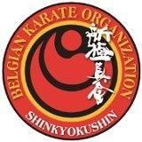
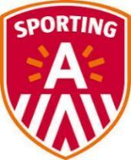

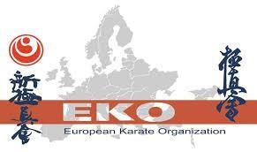
FINANCIAL CONDITIONS

General
Accommodation, flight tickets, transportation, meals and other costs are the sole responsibility for the attendees (participants, referees and officials) unless otherwise noted. Please arrange accordingly with the Country Organization or dojo where necessary.

The participation fee will be € 60, - for each participant, included a memorial t-shirt. Referees will receive a present, free entry and lunch.
Coaches pay a fee of €15,-, there can be two coaches on the tatami.

Tickets: spectators under 16 years old will get free entry, we hope that all dojo leaders bring their students to have a great day and spectacle to motivate them to become a great fighter.

All others pay € 20, -.

All payments must be done through the webshop at our website: www.diamondcup.be

Account information

Account number for Belgian participants | BE29 0017 9267 3164
Account number for international participants | IBAN BE29 0017 9267 3164  BIC GEBABEBB
Account holder | NIJI YAMA VZW  Hemelakkers 1/1, 2930 Brasschaat Belgium

We wish everyone a great tournament and a nice stay in the city of Diamonds.

OSU!
