Shihan Koen Spitaels
Niji Yama Dojo vzw
Shihan Koen Spitaels
Invitation & Guidelines

www.diamondcup.be

Welcome
Dear Presidents, Country Representatives, WKO Branch Chiefs, National Coaches,
Dear Shihan, Sensei, Senpai, Dojo Leaders and Karateka’s.

On behalf of The Belgian Karate Organisation Shinkyokushin BKOS, the European Fullcontact Karate Organisation EFKO and Niji Yama Dojo, we are very honoured and proud to invite you to the
“Antwerp Fullcontact DIAMOND CUP 2023”
The “Antwerp Fullcontact DIAMOND CUP 2023” will take place on Saturday, June 17th in the city of Antwerp, Belgium.
As the preparations of the Antwerp Diamond Cup are ongoing and many volunteers are putting tremendous amounts of effort into the success of this year’s edition, we’re proud to announce the full support of the City of Antwerp.
This document will provide you with more information on the 2023 Antwerp Diamond Cup. As we move towards the event itself, more information will be provided to you if need be by e-mail and through our website www.diamondcup.be. Registration for participants and officials will open officially on March 1st 2023, you can fill in the application form and follow the participation link through kumite technology Kumite Technology. Look for the announcement on our website!
This tournament is open for all fullcontact karate organisations and we work under the guides of the “European Fullcontact Karate organisation”. We are very sure that the family feeling of all karetakas combined with the “Never Give Up Spirit”, will deliver a successful event, giving fullcontact Karate the attention it deserves!
We are very honoured to enjoy the finest competitors of Europe and the world together with you! Friendships will be strengthened and they will unify our Fullcontact karate. Together we will stand strong! Osu!
Shihan Koen Spitaels, Shihan Martin Michel

World Championship I-karate

On behalf of The I-karate Global, and Niji Yama G-warriors, we are very honoured and proud to invite you to the
“5th Open inclusive World Championship”
This WC for karatekas with disability will be held on Sunday June 18th in the Arenahal, Arenhalplein 1, 2100 Antwerp. We invite everybody to join this unique and special tournament where we can show the world that “karate is for everyone” without any exception. Please support this event and come to visit this great I-karate warriors. You can find all info on www.i-k-f.net The tournament is open for all karate styles and organisations and you can join with your student who have a disability.
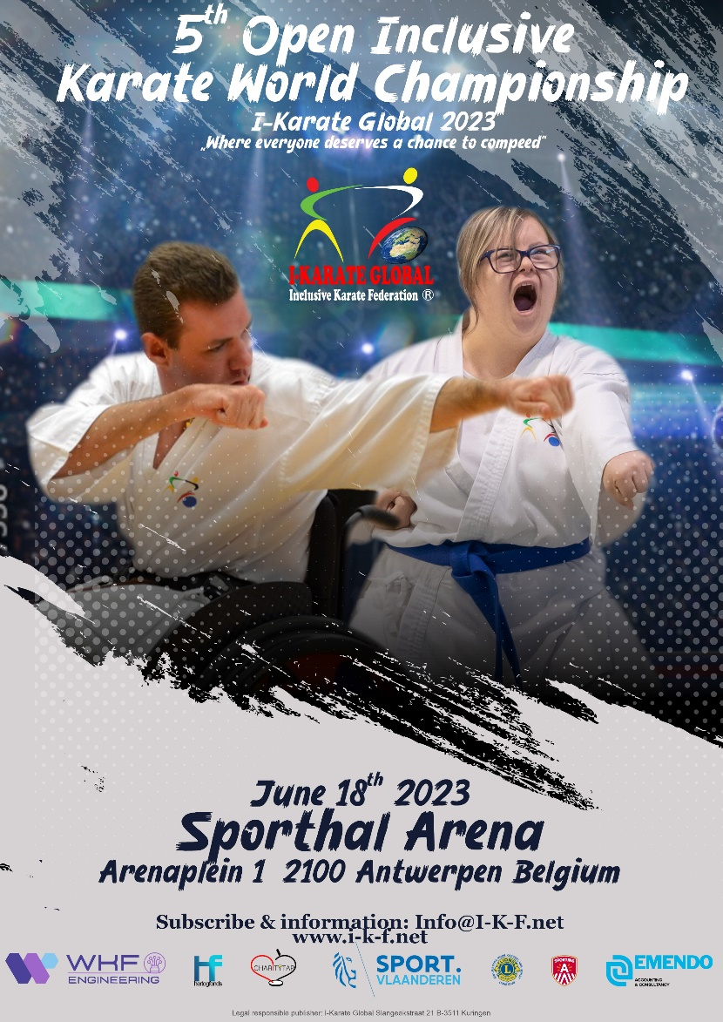

General Information
Official addresses
Event location | Official Hotel | Organisation
Arenahal,  Arenaplein 1  B-2100 Deurne (Antwerp) | The official tournament hotel is the Van Der Valk Hotel Antwerpen. You can book your own accommodation at Van Der Valk or any other hotel of your choosing. Check booking.com for Antwerp | Niji Yama Dojo Vzw  Hemelakkers 1/1  B-2930 Brasschaat

Registrations
Registrations officially open on March 1st, details will be available at Kumite technology. The payments for you and your team can be done through our website www.diamondcup.be.
Deadline for fighters, officials and referees is Friday May 17th, 2023. After this date no more applications or cancellations will be accepted. Registrations can only be accepted when all required documents and payments have been received and processed on time. You will receive a notification when your registration has been accepted.
All participants are requested to present:
- A signed medical certificate (English or Dutch), not older than 3 months.
- A signed certificate of non-pregnancy for all female participants.
- A signed parents approval for underaged participants.
- A signed participant state of health.

More details will be provided after registration if need be.

Categories and number of participants
Kumite - Adults / Seniors ( 18 years and above on the day of the tournament)
Weight classes men |  | Weight classes women
Light weight | -65 kg | Light weight | - 55kg
Middle weight | -75 kg | Middle weight | -60 kg
Heavy weight | -85 kg | Heavy weight | -65 kg
Super heavy weight | + 85 kg | Super heavy weight | +65 kg

Protection men | Protection women
Groin protection | Breast protection (only the cup type is allowed)
Mouth protection (optional) | Shin protection
 | Mouth protection (optional)

Kumite – Juniors (16 -17 years old on the day of the tournament)
Weight classes boys | Weight classes girls
-60 kg | - 55 kg
-70kg | - 65 kg
-80 kg | +65 kg
+80 kg

If there are not enough competitors in a category we will make pools that are safe and reasonable.
Protection boys | Protection girls
Groin protection | Breast protection (only the cup type is allowed)
Shin protection | Shin protection
Closed Head protection | Closed head protection
Mouth protection (optional) | Mouth protection (optional)

The tournament organisation will provide head protection to be used during the fights.
Veterans (40 years and above old and 50 years and above - men only)
-80 kg
+80 kg

Protection men
Groin protection
Mouth protection (optional)
Shin protection (optional)

All fights will be according to the Shinkyokushin WFKO rules, all head kicks allowed (for cadets with closed helmets – a kick to the head has to be controlled and can never be a KO – in that case the fighter who made the kick will be disqualified).

Kata (only blackbelt category male and female)
We will do Kata with flags, like in a pyramid system. Preliminary rounds: obligatory kata (Tsukino kata, Yantsu Kata, Gekisai dai kata, Saiha kata, Gekisai sho kata). From ¼ finals: kata of your own choosing.
Number of Participants
Every country/organisation/dojo can enter 4 competitors in each category.
Trophy’s and presents
There will be trophies for the first 4 competitors in each category (except in pool categories). For all categories every 1st place winner will receive a diamond (with a diamond certificate).
Photo’s Video
Everybody is allowed to make photos and video tapes All info: Diamondcup.Antwerp@gmail.com.
Draw
Because the Diamond Cup is a tournament organized every 2 years and including all organisations we will not use a ranking to match fighters. Every fighter will be equal for the draw. Of course we will try to avoid fighters from the same country and/or dojo from having to fight each other in the first round.
On the website you can scan the QR code to use the tournament app of Kumite technology, When the draw is made.
At arrival and check-in, everyone will receive an updated and detailed schedule. For specific questions, please send an e-mail to Diamondcup.Antwerp@gmail.com.

Preliminary Schedule
Friday June 16th
 | Arrivals Teams , officials, referees
16.00 - 18.00 | Referee meeting in sports hall
15.00 - 17.30 | Weight and medical check in sports hall
18.00 - 20.30 | Weight and medical check in sports hall
21.00 | Draw for coaches in sports hall
Saturday June 17th | Antwerp Diamond Cup
08.00 | Doors Open
08.30 | Referee meeting
09.00 | Coach meeting
09.00 - 10.00 | Weight control – for those not yet checked in
09.30 | Start Tournament – taiko drum
09.40 | Start kata on 2 tatami
11.00 | Start kumite on 3 tatami
14.00 | Break
14.30 | Official opening
15.00 | 1/4 finals
17.00 | Finals
18.00 | Trophies
20.00 | Sayonara party in sports hall
Sunday June 18th | World Championship I-karate
08.00 | Doors Open
08.30 | Referee meeting
09.00 | Coach meeting
09.30 | Official opening
10.00 | Start Tournament
 | 4 tatami's
13.00 | Trophies first part
13.30 | Break
14.00 | Start second part
 | 4 tatami's
18.00 | Trophies second part

For those who can’t come to the weight and medical check on Friday, there will be a weight and medical check on Saturday morning in the sports hall, BUT! Your weight has to be correct, because we make the draw on Friday evening. So if your fighter is too heavy we will cancel him/her from the tournament. No excuses will be allowed!
Accommodation
The official tournament hotel is the Van Der Valk Hotel Antwerp. The organisation, officials and most competitors and coaches will stay there. You can book your own accommodation directly at the Van Der Valk Hotel. However, you are also free to book in any accommodation of your own choosing. You can check Booking.com to find a suitable hotel or B&B. All official matters (referee course, weight check, sayonara party), will be held in the sports hall Arenhal, Arenaplein 1, 2100 Antwerpen.
Sayonara Party
The Sayonara party (buffet form) costs € 30,- per person but is free for participants and referees. Drinks are not free. Tickets can only be ordered on the website.
Participation and entrance
Accommodation, flight tickets, transportation, meals and other costs are the sole responsibility for the attendees (participants, referees and officials) unless otherwise noted. Please arrange accordingly with the Country Organisation or dojo where necessary.
The participation fee will be € 60,- for each participant. The following is included: Sayonara party, lunch on the day of the tournament, event t-shirt and gadgets. Referees receive a present, free ticket for the Sayonara party and free entrance and lunch on the day of the tournament. Coaches have a free entrance.
Entrance for spectators under 16 years old will be free, we hope that all dojo leaders bring their students to have a great day and enjoy a big spectacle to motivate them to become a great fighter. All other visitors pay € 20,-.
All payments have to be done on our website www.diamondcup.be
T-shirt
https://www.kyokushinworldshop.com/nl/ will make a great unique t-shirt for the Diamond Cup. For fighters this t-shirt is free, all others can order it in our webshop for € 25,-.

Account information
Account number for Belgian participants | BE29 0017 9267 3164
Account number for international participants | IBAN BE29 0017 9267 3164  BIC GEBABEBB
Account holder | NIJI YAMA VZW  Hemelakkers 1/1, 2930 Brasschaat  Belgium

Contact
Shihan Koen Spitaels
Sensei Twan Smolders
Diamondcup.Antwerp@gmail.com
www.diamondcup.be

We wish everyone a great tournament and a nice stay in the city of Diamonds. OSU!
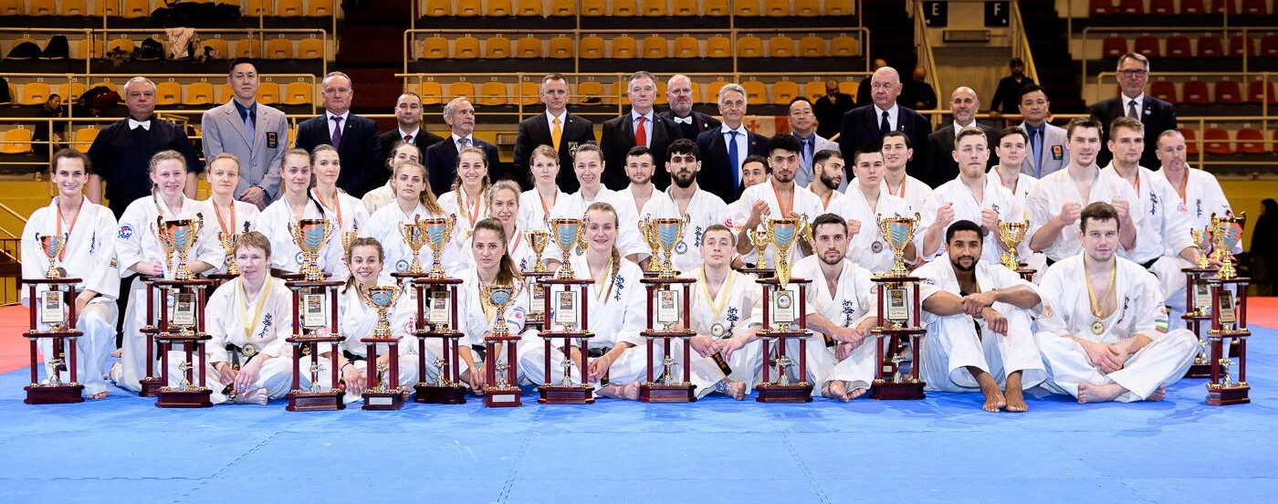

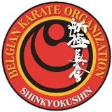

Changes might occur in the best interest of the event. Please contact Diamondcup.Antwerp@Gmail.com if you have any questions.

